MORC Stn 26
Double Handed Series
June 5/23, July 10/23, Aug 14/23, Sept 18/23

SAILING INSTRUCTIONS

1. RULES
1.1 The series races will be governed by the ‘rules’ as defined in The Racing Rules of Sailing 2021-2024(RRS).
1.2 The prescriptions of the Canadian Yachting Association (CYA) will apply.
1.3 The use of an Auto helm is permitted for these races.

2 ELIGIBILITY AND ENTRY
2.1 This series race is open to all skippers and crew who wish to sail in a double handed Series.

3 NOTICE TO COMPETITORS
3.1 Notice to competitors will be posted on the official regatta notice board located at SYC and the SYC race page at sarniayachtclub.ca . Any such notice or absence of notice shall not be relied upon as official.

4. CHANGES IN SAILING INSTRUCTIONS
4.1 Any changes in the sailing instructions shall be posted before 12:00 on the day of the race.

5. SIGNALS MADE ASHORE
5.1 Signals made ashore will be displayed at the SYC Race Committee Building on the Flagstaff.
5.2 When the flag AP is displayed ashore, ‘1 minute’ is replaced with ‘not less than 90 minutes’ in race signal AP.

6. SCHEDULE OF EVENTS
6.1 The scheduled time of the warning signal for the races is 18:05.

7. MEASUREMENT AND RATING
7.1 Yachts racing with a PHRF rating should have a current handicap from MWPHRF Association. Other PHRF Association certificates can be submitted, but will be subject to modification by the MWPHRF Association. One-design classes shall have proper one design certificate. MWPHRF Association will govern all ratings.

8. CLASS SPLITS
8.1 Splits will be posted by 12:00 the day of the first race on the SYC race page and the notice boards.

9. THE COURSE
9.1 The octagon course is illustrated in Appendix 1.
9.2 The designated course length is shown in section 21.
9.3 Race #1, 2, 3 & 4 will be: Start M-B-D-F-X-Finish, mark F will be rounded to port. Marks B, D & X are rounded to starboard.

9.4 Short Course will be: Start M-F-E-M-X-Finish, mark M will be rounded to port, mark X will be rounded to starboard.

10 MARKS
10.1 Marks A, B, C, D, E, F, G, H, and X are 4’ diameter yellow balls marked with a black letter. Mark CC is a 4’ diameter white ball marked with black letters. R2 is a RED channel navigation buoy.
10.2 Marks that are damaged but still visible are still to be considered proper marks. Marks that are missing or substantially off-station may be replaced by marks that meet one of the following conditions (Modifies RRS 34):
- 4’ diameter white or yellow ball with no letter identification.
- A buoy or stake-boat displaying an M Code Flag.
- An inflatable orange (or other color) pyramid buoy.
10.3 Green inflatable pyramid may be used as a limit mark for the Race Committee Boat. This mark will be considered to be a part of the Race Committee boat.

11. THE START
11.1 Starting signals will be made at five-minute intervals. Each signal will be removed one minute before the next is raised. Warning: Yellow Flag, One Sound. Preparatory: Blue Flag, One Sound. Start: Red Flag, One Sound. This changes RRS 26. Times will be taken from the visual signals; absence of a sound signal will be disregarded.
11.2 The starting line shall be between a staff displaying the Orange Flag on the Race Committee boat at the port end, and the M mark at the starboard end. A distance of 100ft back from both marks will form the start box.
11.3 Restricted Area - Yachts whose warning signal has not been made shall keep clear of the start box and all yachts whose warning signal has been made.
11.4 The starting order and specific courses for each class will be posted on the race notice board by 12:00 the day of the first race.

12. THE FINISH
12.1 The finishing line will be between the R-2 navigation buoy to starboard and the red stripe on the SYC race shack to port.
12.2 After finishing, boats shall not obscure the Race Committee’s vision of the finish line and stay clear of boats still racing. Boats should not re-cross the finish line with sails up after finishing.
12.3 Boats shall record their finish times, and the boat immediately ahead and astern. Times should be reported to the Race Committee if requested.
The US Coast Guard has advised that some commercial traffic may be under escort through the St. Clair River and the Lake Huron shipping channel out to #11 & #12 buoys. Skippers are reminded that all larger commercial vessels have the right-of-way in these areas and must use caution when approaching or crossing the channel when a freighter is present, especially at #2 buoy when finishing a race.

13. RETIREMENT
13.1 Yachts retiring from the race shall identify themselves to the SYC Race Committee by hailing VHF Ch. 69 or by calling 519-332-6779 ext 6 for the purpose of reporting. The skipper must also inform the race chairman once ashore. Failure to meet this obligation could result in a protest and penalty by the Protest Committee.

14. TIME LIMIT
14.1 There is no time limit for these races.
14.2 Boats that finish after 21:00 will take their own finish time. Upon docking, the finish time shall be reported to the Race Committee.
15. SAFETY REGULATIONS
15.1 The safety of a yacht and its crew is the sole responsibility of the owner or skipper, who shall ensure that the yacht is fully sound, thoroughly seaworthy and that the skipper and crew are capable and fit for the passage.
15.2 Each yacht racing, depending on the country of registration, shall comply with US or Canadian Coast Guard requirements.
15.3 Every effort MUST be made to avoid interference with Great Lakes Shipping.

16 PROTESTS
16.1 The protest time limit is 90 minutes after the finish time of the protesting yacht.
16.2 All protests must be filed in person at SYC or by phoning SYC race shack from PHYC.
16.2 All protests will be heard at SYC.

17 ALTERNATIVE PENALTIES
17.1 Racing rule (RRS) 44.3 scoring penalty will not apply.

18 RADIO COMMUNICATION
18.1 At the start, the Race Committee may monitor and use VHF 69 to hail sail numbers of infringing yachts. Failure to do so will not be grounds for redress.
18.2 It is strongly recommended that all yachts monitor communications on VHF 16 & 69 while racing

19 SCORING
19.1 The Low Point Scoring System, appendix A4.1 of the Racing Rules will apply.

20 AWARDS
  - Awards will be made to the top three finishers in each class for the series.

21 COURSE
21.1 Course length is 8.96 nm

Short course length is 4.58 nm

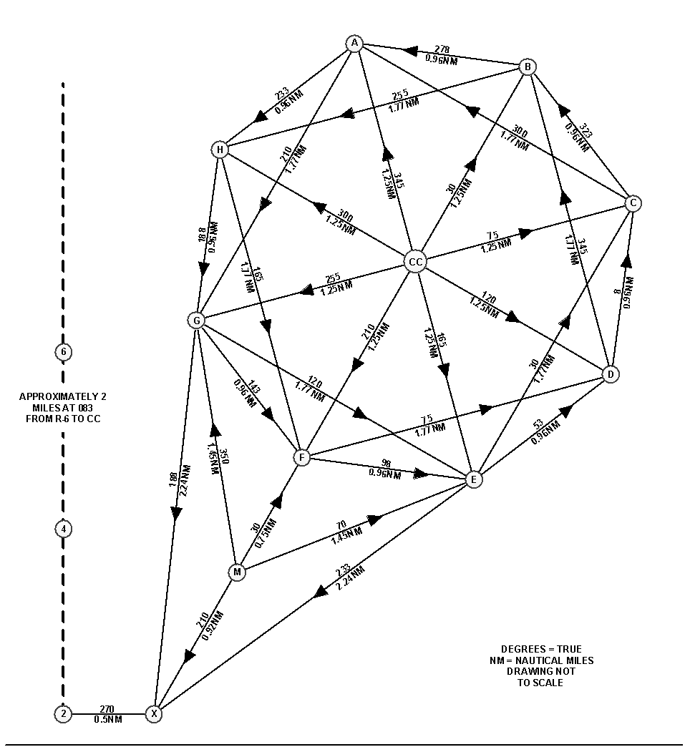
Mark | Latitude’ | Longitude’
A | N 43° 04.252’ | W 82° 22.610’
B | N 43° 04.140’ | W 82° 21.321’
C | N 43° 03.393’ | W 82° 20.544’
D | N 43° 02.419’ | W 82° 20.696’
E | N 43° 01.841’ | W 82° 21.712’
F | N 43° 01.929’ | W 82° 23.046’
G | N 43° 02.714’ | W 82° 23.853’
H | N 43° 03.667’ | W 82° 23.652’
CC | N 43° 03.015’ | W 82° 22.197’
M | N 43° 01.306’ | W 82° 23.598’
X | N 43° 00.530’ | W 82° 24.266’

